Marystowe Jigsaw Library
Catalogue
Spring 2021

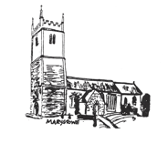

We have a large collection of donated Jigsaws available to be borrowed. We have listed these Jigsaws (with pictures) in this catalogue.

All the Jigsaws are kept in the Church at Marystowe. As the Church is locked (except for services) we are happy to deliver/collect the Jigsaws for free, but we will be making a small charge through membership of the Jigsaw Library. All proceeds will be for the Church; the production of the catalogue, sorting and deliveries is all undertaken by volunteers.

Membership of the library is £5 – which is £1 deposit and 4 credits. Each credit represents the loan of one jigsaw.

Only one jigsaw can be borrowed at a time (to leave choice for everyone).

We have been donated the jigsaws and understand all are complete. If you find a piece missing please let us know so we can remove it from circulation and re-credit you.

All Jigsaws are quarantined for 72 hours before being re-lent.

Please call Joy McSmythurs 01822 860630 or Barbara Dawe 01566 784797 to join and have your puzzles delivered.

Picture (Art) Puzzles

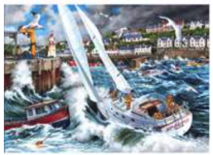 | 1000 pieces | M001
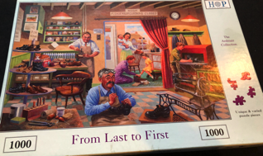 | 1000 pieces | M009
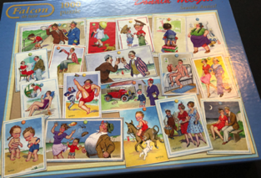 | 1000 pieces | M010
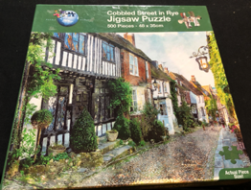 | 500 pieces | D004
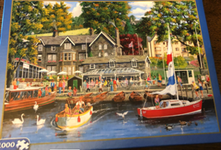 | 1000 pieces | M031
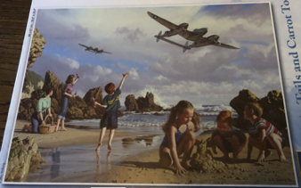 | 1000 pieces | M021
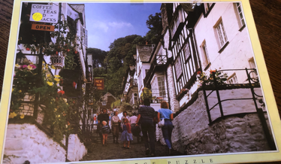 | 1000 pieces | M022
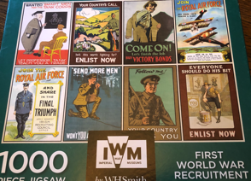 | 1000 pieces | M023
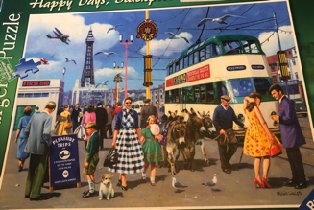 | 1000 pieces | M024
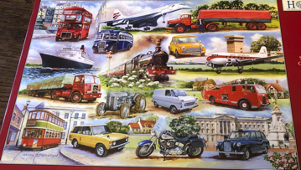 | 1000 pieces | M025
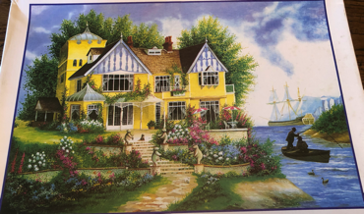 | 1000 pieces | M026
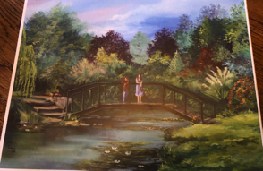 | 1000 pieces | M028
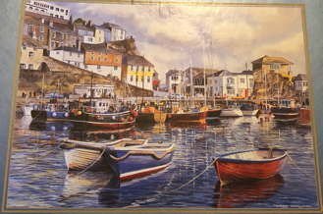 | 1000 pieces | M033
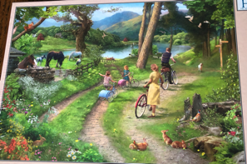 | 250 large pieces | CCL001
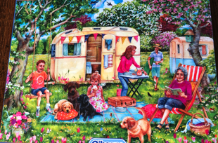 | 250 extra large pieces | CCL002
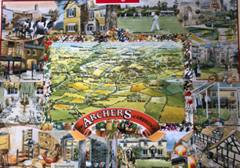 | 1000 pieces | M036
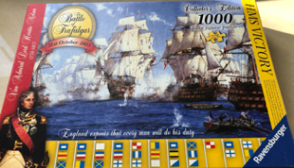 | 1000 pieces | M042
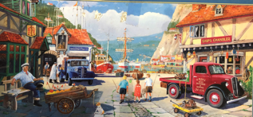 | 636 pieces | DC1
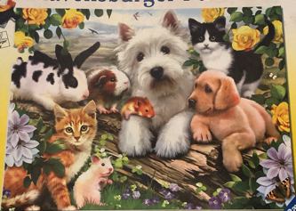 | 300 pieces | CCC01
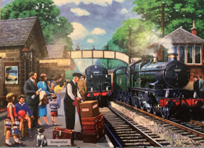 | 1000 pieces | M045
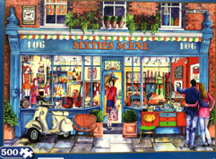 | 500 pieces | D009
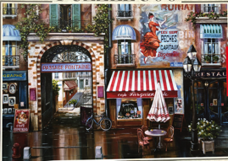 | 500 pieces | D010
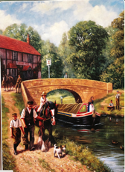 | 500 pieces | D011
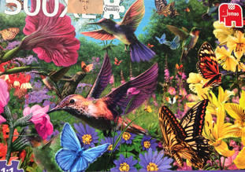 | 500 pieces  Extra large | D008
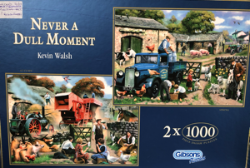 | Two puzzles – one with a missing piece  Both 1000 pieces | M047
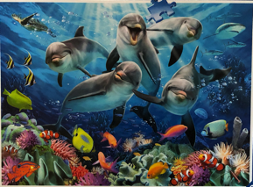 | 500 pieces | D017
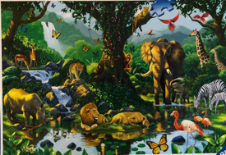 | 500 pieces | D018
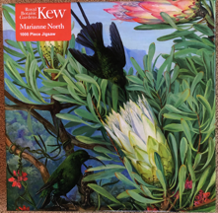 | 1000 pieces | M049
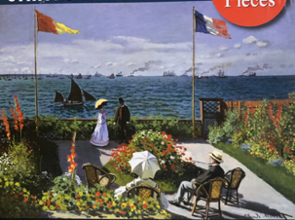 | 1000 pieces | M050
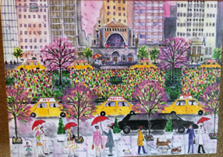 | 1000 pieces | M051
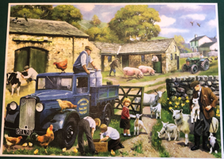 | 1000 pieces | M054
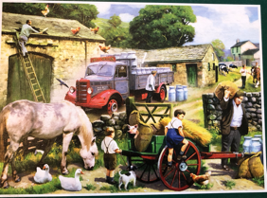 | 1000 | M055
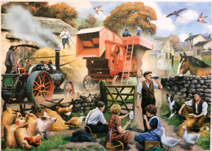 | 1000 | M056
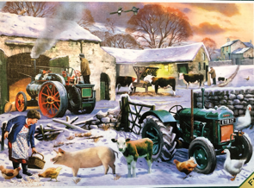 | 1000 | M057
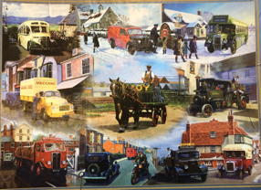 | 1000 pieces | M059
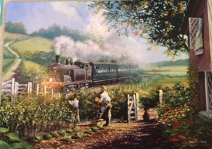 | 1000 pieces | M060
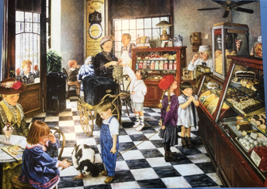 | 1000 pieces | M061
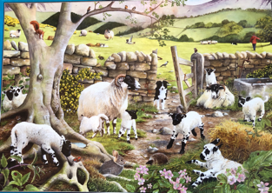 | 1000 pieces | M062
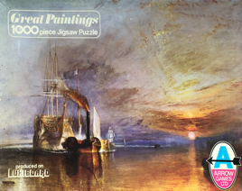 | 1000 pieces | M064
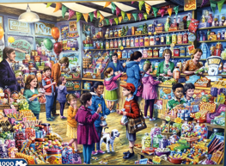 | 1000 pieces | M065
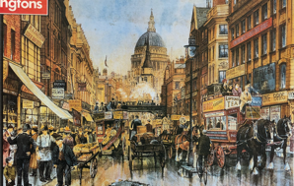 | 500 pieces | D021
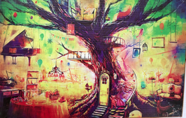 | 1000 pieces | M068
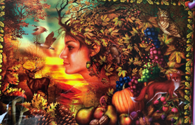 | 1000 | M071
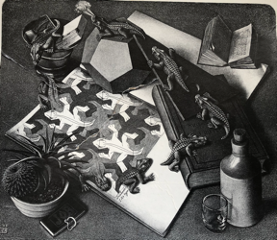 | 1000 pieces | M072
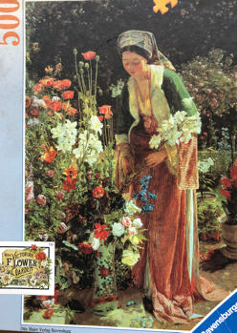 | 500 pieces | D024
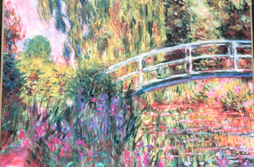 | 1000 pieces | M073
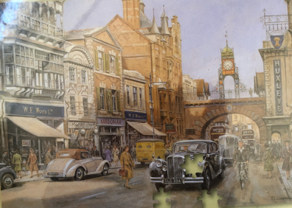 | 1500 pieces | MD002
Picture (photo) Puzzles

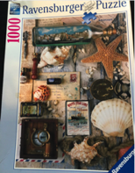 | 1000 pieces | M002
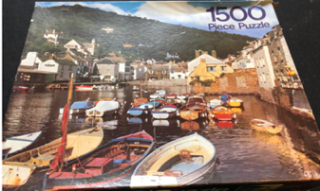 | 1500 pieces | MD001
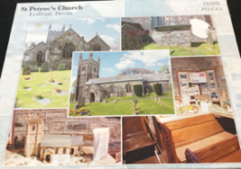 | 1000 pieces | M016
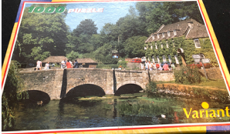 | 1000 pieces | M017
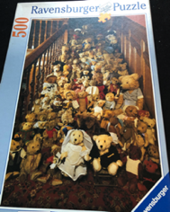 | 500 pieces | D003
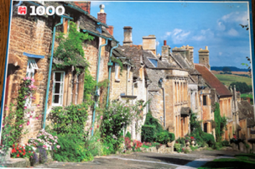 | 1000 pieces | M035
 | 500 pieces | D002
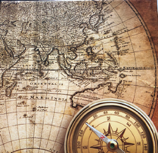 | 500 pieces | D001
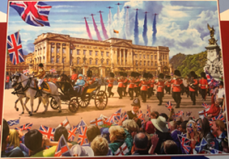 | 500 pieces | D006
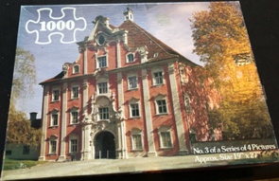 | 1000 pieces | M020
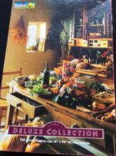 | 750 pieces | DCCL001
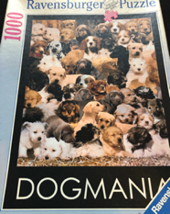 | 1000 pieces | M018
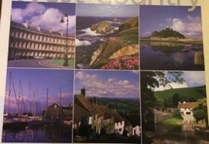 | 1000 pieces | M034
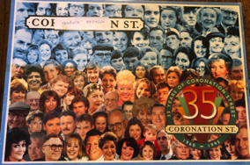 | 1000 pieces | M032
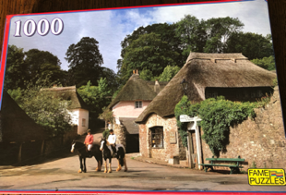 | 1000 pieces | M038
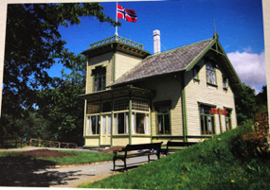 | 1000 pieces | M039
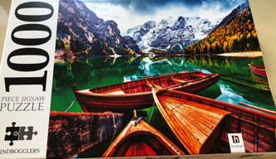 | 1000 | M041
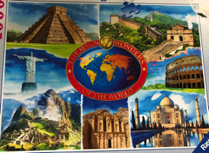 | 1000 | M043
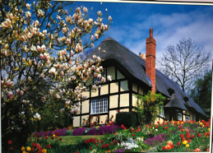 | 1000 | M044
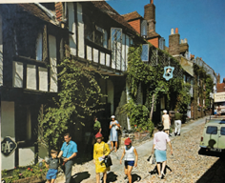 | 600 pieces | DC2
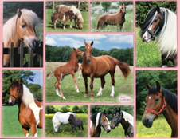 | 300 pieces  Extra extra Large | CCC02
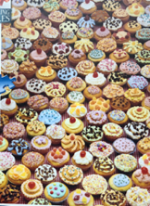 | 500 pieces | D014
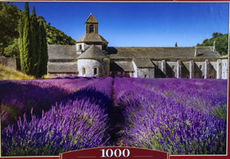 | 1000 pieces | M052
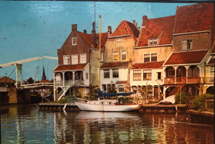 | 1000 pieces | M053
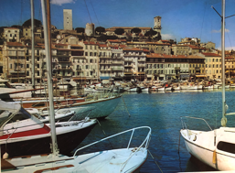 | 2000 pieces | MM01
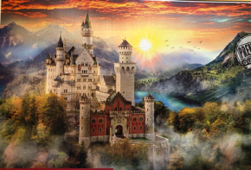 | 2000 pieces | MM02
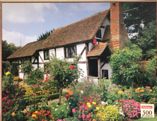 | 500 pieces | D019
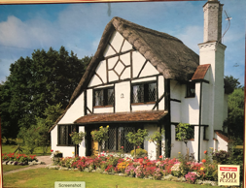 | 500 pieces | D020
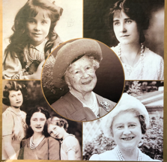 | 1000 pieces | M066
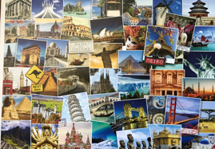 | 1000 pieces | M067
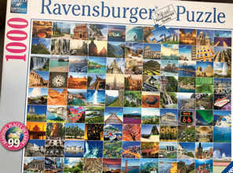 | 1000 pieces | M070
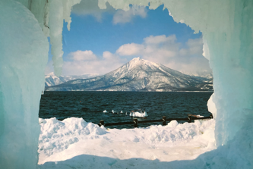 | 1000 pieces | M074
The puzzle below is a photo of Venice probably 500-1000 pieces?
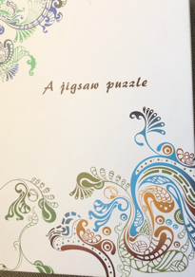 | Unknown | N001
Cartoon Puzzles

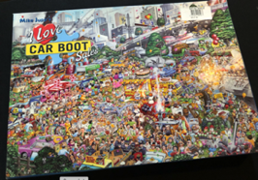 | 1000 pieces | M006
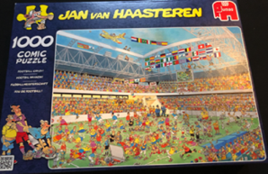 | 1000 pieces | M007
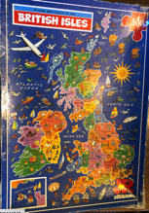 | 500 pieces | D007
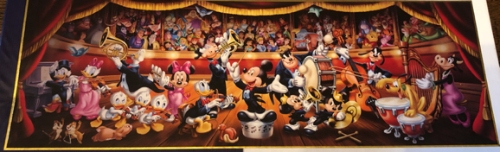 | 1000 pieces | M030
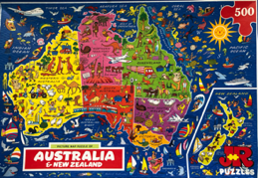 | 500 pieces | D012
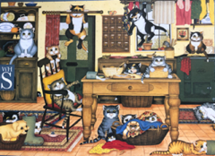 | 1000 pieces | M046
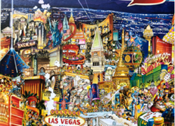 | 500 pieces | D013
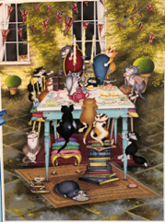 | 500 pieces | D015
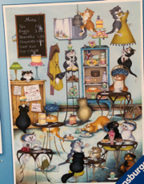 | 500 pieces | D016
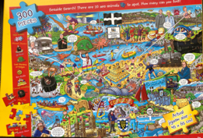 | 300 large pieces | CCC03
Cartoon Puzzles – What If
With all What If? Jigsaw puzzles, the picture you puzzle is not the same as the picture on the box.
Follow the visual clues as you complete the jigsaw, to discover the actual outcome.

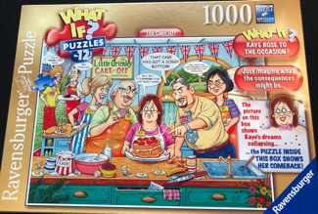 | 1000 pieces | M003
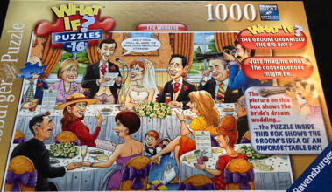 | 1000 pieces | M008
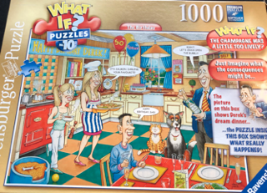 | 1000 pieces | M011
Cartoon Puzzles –
Wasgij original
The picture on the box is not the picture you will be puzzling! The puzzle requires imagination (and a few clues provided) to put yourself in the position of a particular character that appears in the picture shown on the box and imagine what that character is looking at.
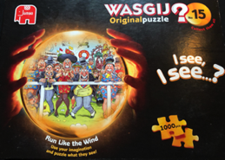 | 1000 pieces | M004
Cartoon Puzzles –
Wasgij Back to…
The picture on the box is not the picture you will be puzzling. Instead recreate how it would have been in the past
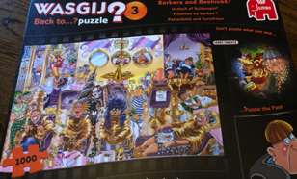 | 1000 pieces | M029
Cartoon Puzzles –
Mirror Image
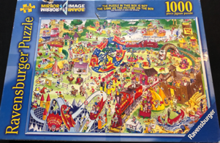 | 1000 pieces | M005
Cartoon Puzzles –
Double Sided
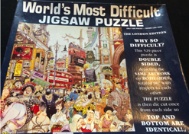 | 500 pieces | D005
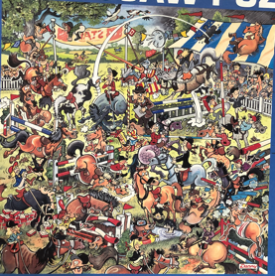 | 500 pieces | D022
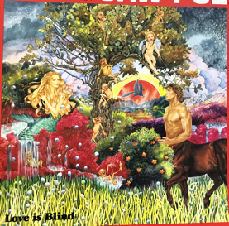 | 500 pieces | D023
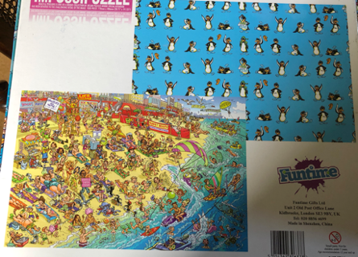 | 1000 pieces | M040
Wooden puzzles
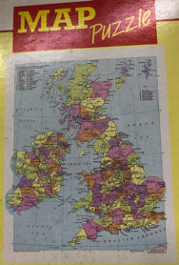 | 100 pieces | C001
Jigraphy
These puzzles are maps of UK towns and cities
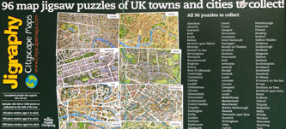 | 1000 pieces  Map of Plymouth | M063
Photomosaic
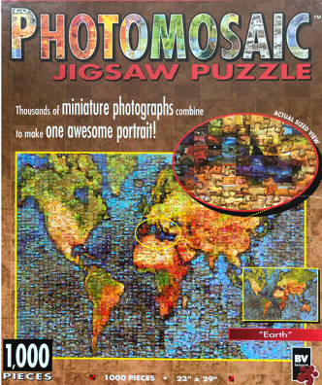 | 1000 pieces | M069

